Web Application Testing Lab

Manual Testing
Simulating testing by login onto the DVWA
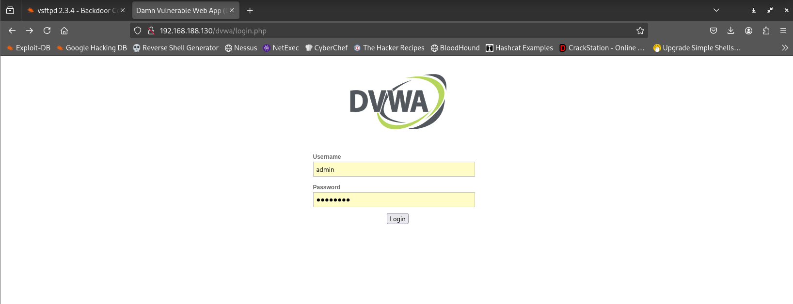
Then with our Burpsuite running go to the proxy tab and turn on intercept
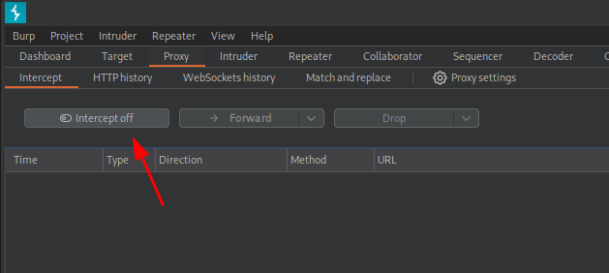
Turn on our Foxyproxy to proxy our requests through the Burpsuite
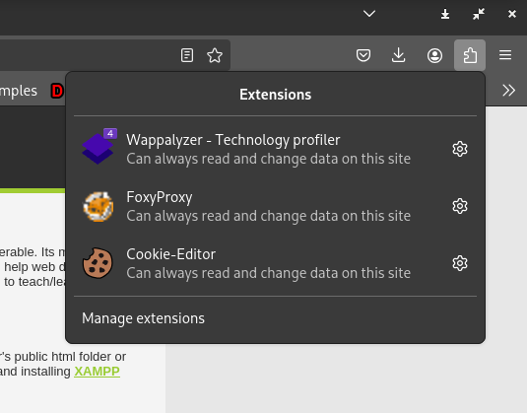
Refresh the page DVWA homepage
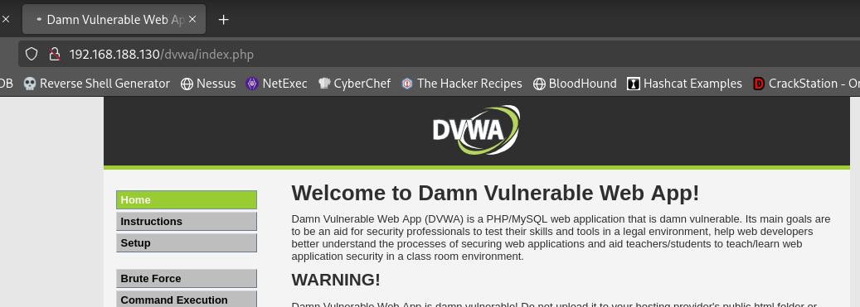
We can see request being intercepted
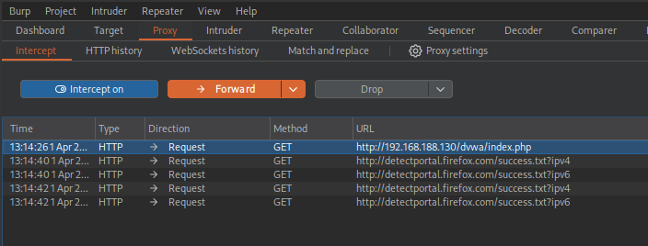
From here we can get the get the session token
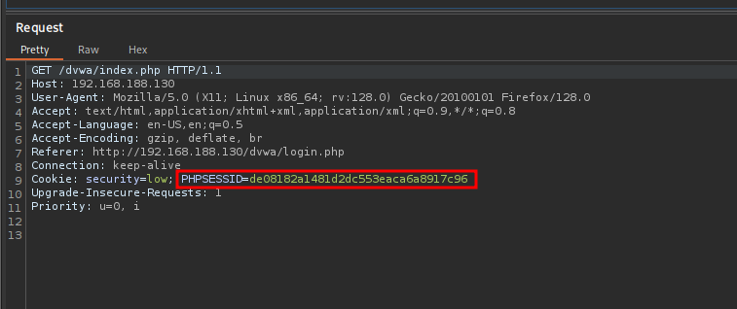
This can further lead to session impersonation

